FOR IMMEDIATE RELEASE [Date]

­[YOUR CITY] LOCAL TO [RIDE/ HIKE] [TENS/ HUNDREDS] OF MILES FOR THE FUTURE ON [YOUR CLIMATE RIDE EVENT NAME] 2020
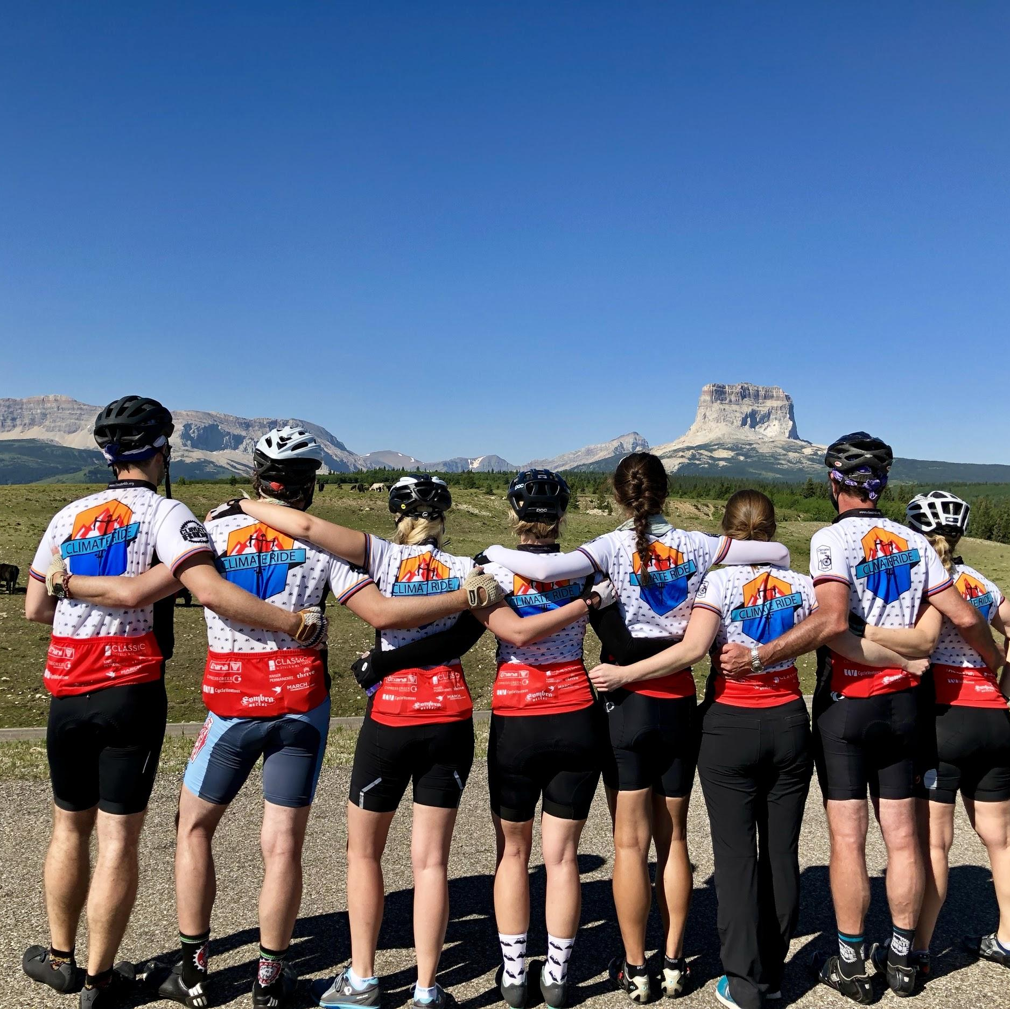
[City], [ST], [Date]– {Intro to the event, the basics}: [YOUR NAME] is slated to participate in Climate Ride [EVENT], a multi-day [run/cycling/hiking] fundraiser organized by Climate Ride, with participants riding/hiking/running approximately 300 miles. The ride/hike/run will take place from [Month, Day] through [Day], 2020, and is designed to raise awareness of sustainability, clean energy, climate change issues, active transportation, and public health.

{QUOTE about why this is important to you. Feel free to write your own or
update this} “It will be challenging to ride hundreds of miles of hills and mountainous terrain,” said [YOUR NAME], a resident of [YOUR CITY]. “But the issues and the organizations that Climate Ride support are critical. I am fundraising and pushing myself to do this ride to inspire people to take action in their day-to-day lives. Climate Ride is about awareness and exchanging ideas, resolving serious issues that will affect our future, and doing something I believe in.”

This [Month], [LAST NAME] will join other participants who each raised thousands of dollars to benefit one of more than 100 organizations including National Parks Conservation Association, Rails-to-Trails Conservancy, NRDC, 350.org, Citizens Climate Lobby, World Bicycle Relief, Environmental Defense Fund, 1% For the Planet, [add your beneficiary to the list] and dozens of active transportation coalitions throughout the U.S.

{Paragraph about you. Feel free to update or write your own, but please don’t claim children, dogs, or cat that don’t exist.} [LAST NAME] is the [job position], responsible [list responsibilities]. [LAST NAME] is a proud [mother/father/aunt/uncle/caretaker] of [number] [children/dogs/cats], which is why she/he/they works so diligently for a better future. This will be his/her/their first Climate Ride and she’s/he’s/their currently training by riding/hiking more than [150] miles per week.

Climate Ride, a 501(c)3 nonprofit organization that puts together active charitable events to raise money for and awareness of sustainability, environmental causes, public health,and active transportation including bicycle advocacy. Participants will ride approximately 60 miles a day and along the way will see and learn first-hand about how climate change is affecting [YOUR CITY, STATE]. Since 2008, Climate Ride has granted over $6 Million to sustainability and active transportation nonprofits. Those interested in a multi-day bike ride or hike can register for a Climate Ride event at http://www.climateride.org/.
# # #
If you would like more information, please contact Caeli Quinn at Climate Ride or email caeli@climateride.org .

